

# Practices for Secure Software Report

Table of Contents

Document Revision History 3

Client 3

Instructions 3

Developer 4

1. Algorithm Cipher 4

2. Certificate Generation 4

3. Deploy Cipher 4

4. Secure Communications 4

5. Secondary Testing 4

6. Functional Testing 4

7. Summary 4

8. Industry Standard Best Practices 4

## Document Revision History

| **Version** | **Date** | **Author** | **Comments** |
| --- | --- | --- | --- |
| **1.0** | **12/14/2025** | **Kyle Gortych** |  |

## Client



## Instructions

Submit this completed practices for secure software report. Replace the bracketed text with the relevant information. You must document your process for writing secure communications and refactoring code that complies with software security testing protocols.

* Respond to the steps outlined below and include your findings.
* Respond using your own words. You may also choose to include images or supporting materials. If you include them, make certain to insert them in all the relevant locations in the document.
* Refer to the Project Two Guidelines and Rubric for more detailed instructions about each section of the template.

## Developer

Kyle Gortych

## Algorithm Cipher

SHA-256

## Certificate Generation

Insert a screenshot below of the CER file.

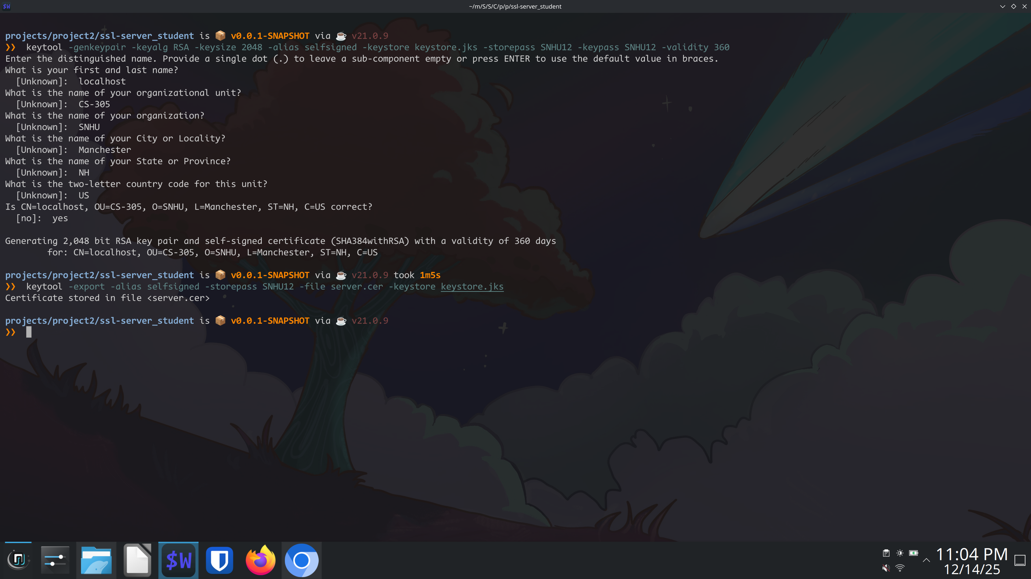

## Deploy Cipher

Insert a screenshot below of the checksum verification.

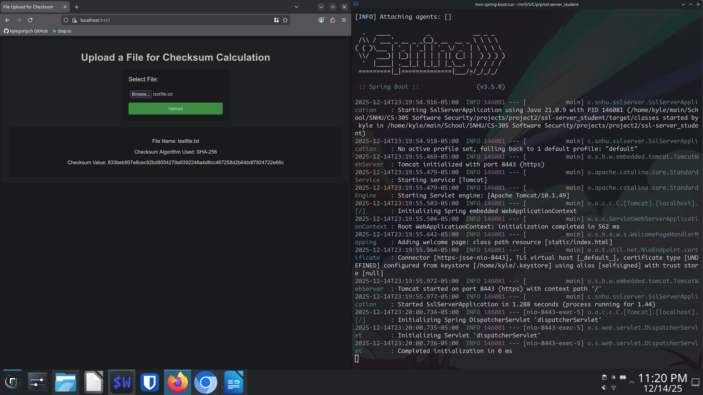

## Secure Communications

Insert a screenshot below of the web browser that shows a secure webpage.

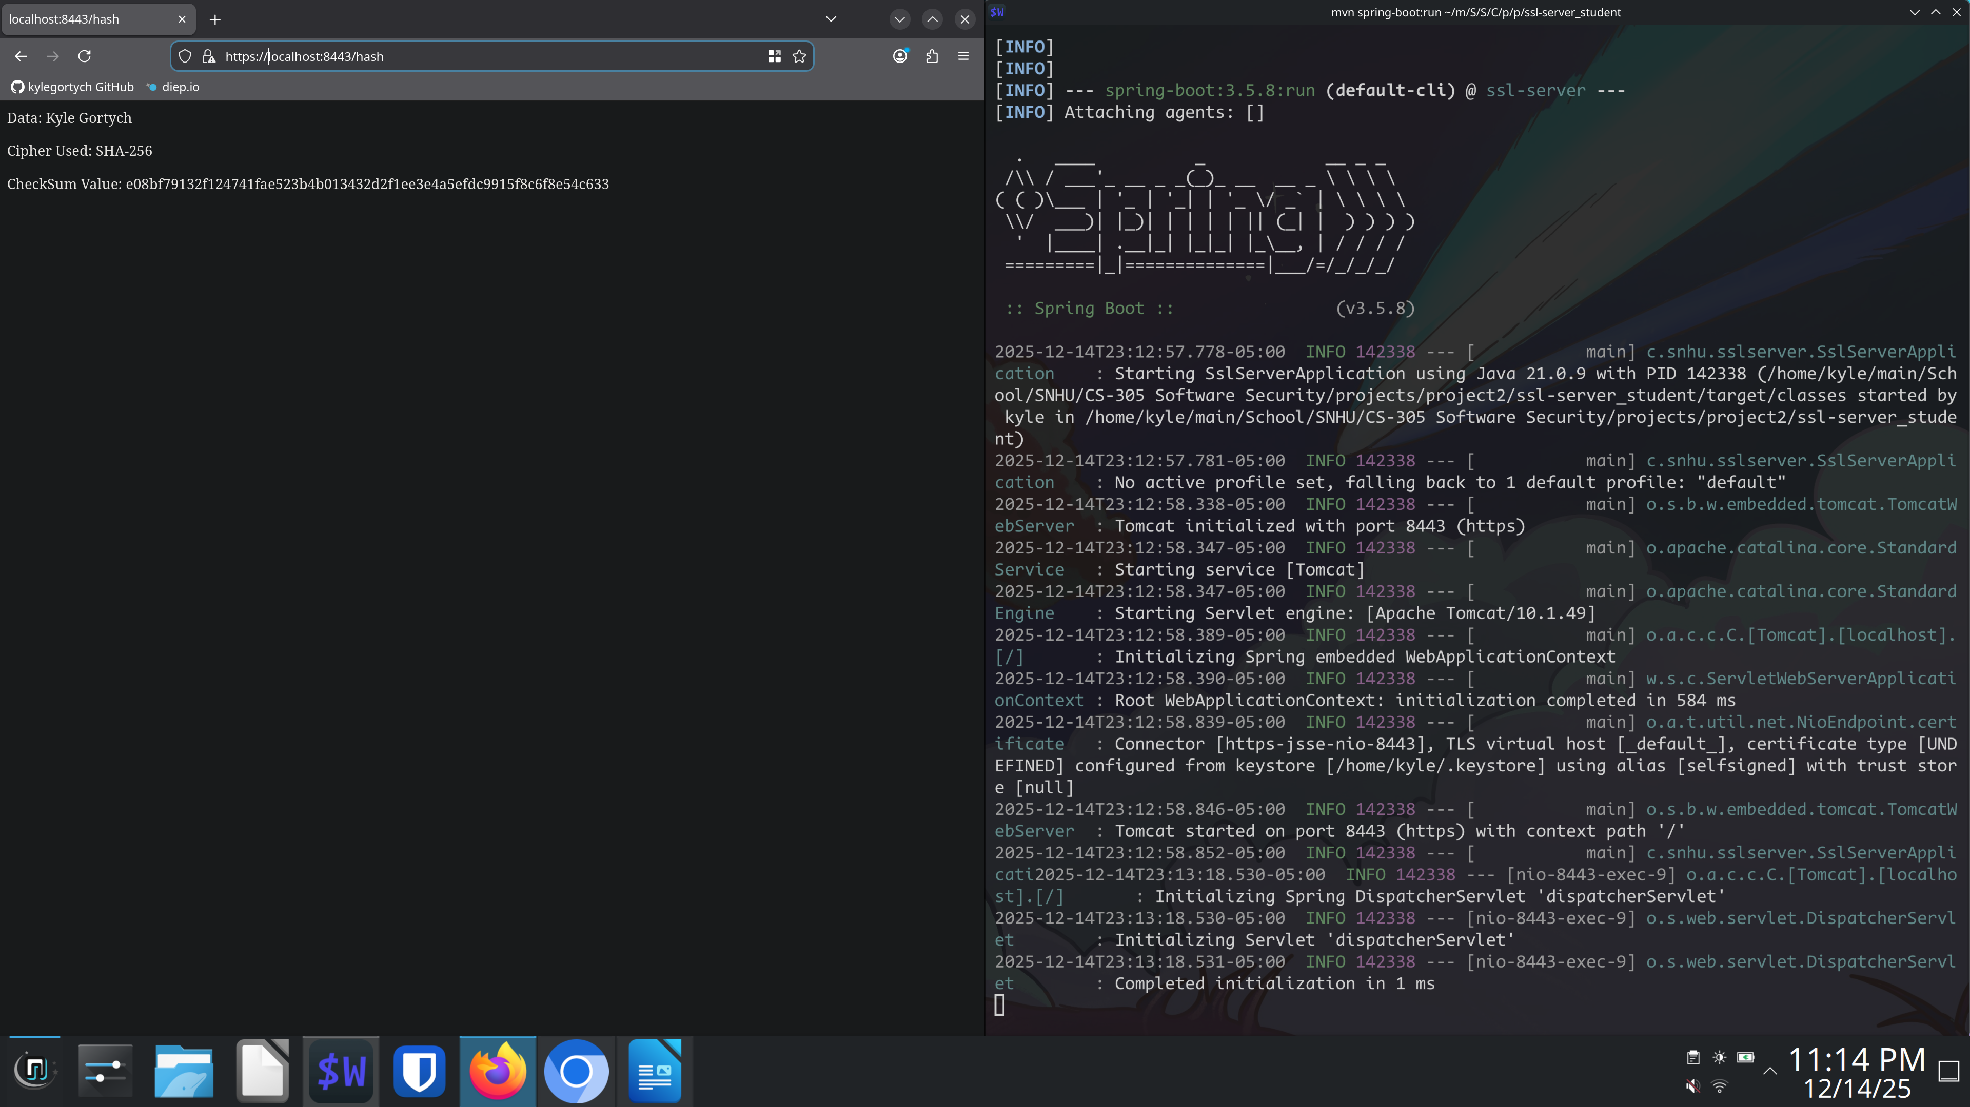

## Secondary Testing

Insert screenshots below of the refactored code executed without errors and the dependency-check report.

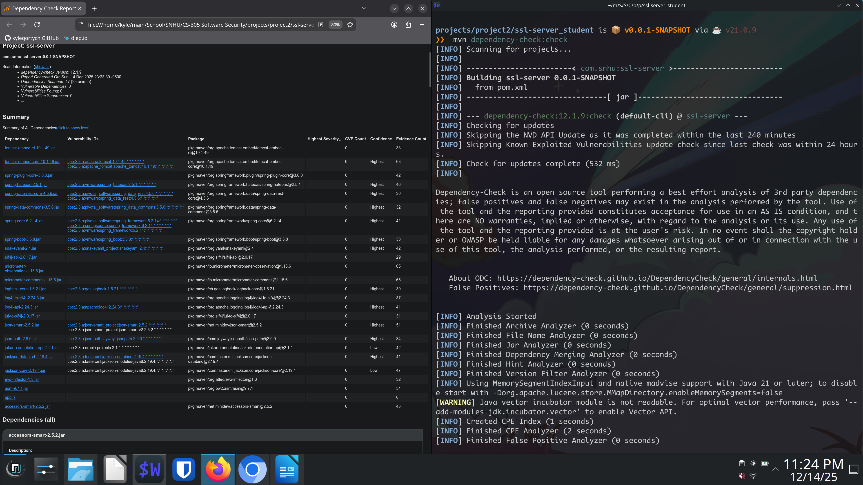

## Functional Testing

Insert a screenshot below of the refactored code executed without errors.

SslServerApplication.java file:

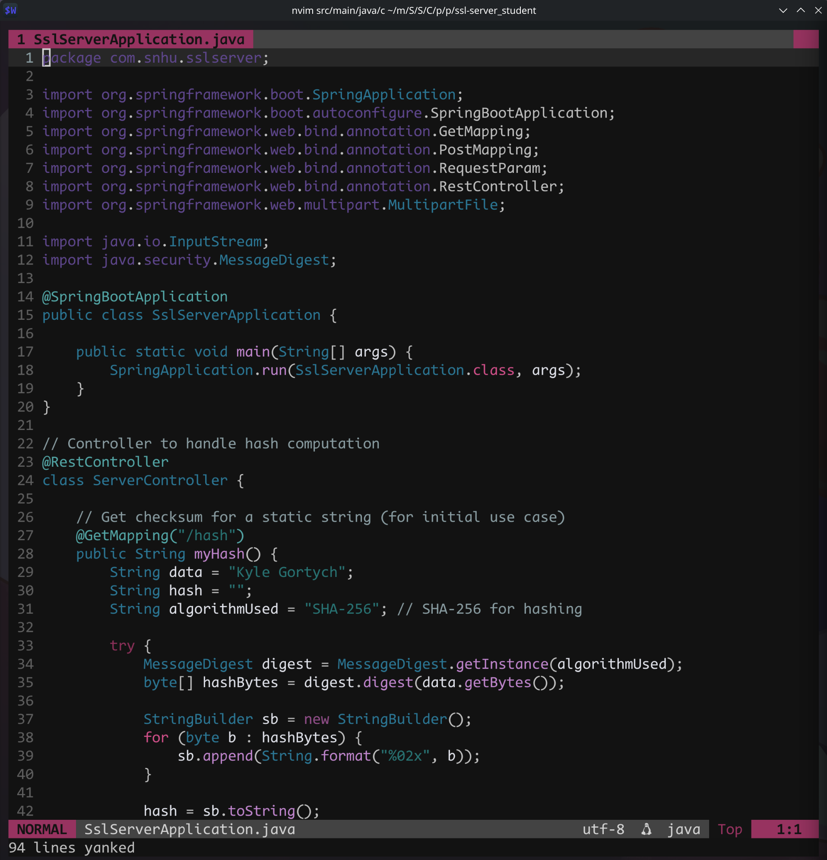

SslServerApplicationTests.java file:

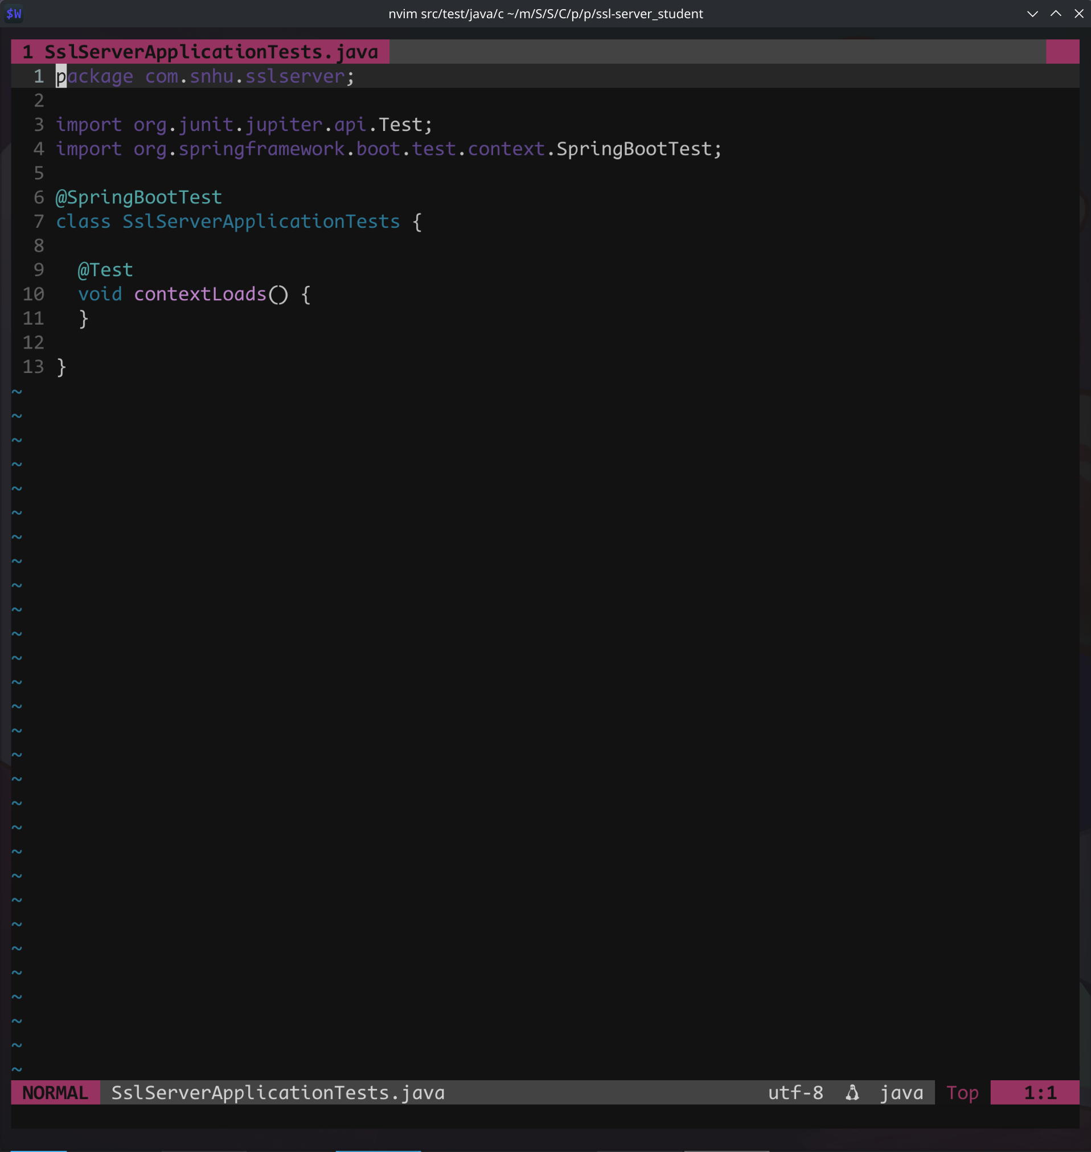

## Summary

The source code has be refactored to comply with standard best practices. In updating to the latest dependency versions and ensuring source code is designed to protect data types with private key word. Local tools for scanning the source code such as opengrep help to resolve possible seciurty errors. For automating the process github code scanning tools can be implemented as well.

## Industry Standard Best Practices

Updated to the latest stable main dependencies to pull and resolve any transitive dependency vulnerabilities and deprecated functions. The application is in a state were testing can be implemented for functionality and verification for end-user file sha hash.